CS1231

Proof Techniques:

Direct, Contrapositive, Induction & Strong Induction, Contradiction

Propositional Logic:

Impt Tables: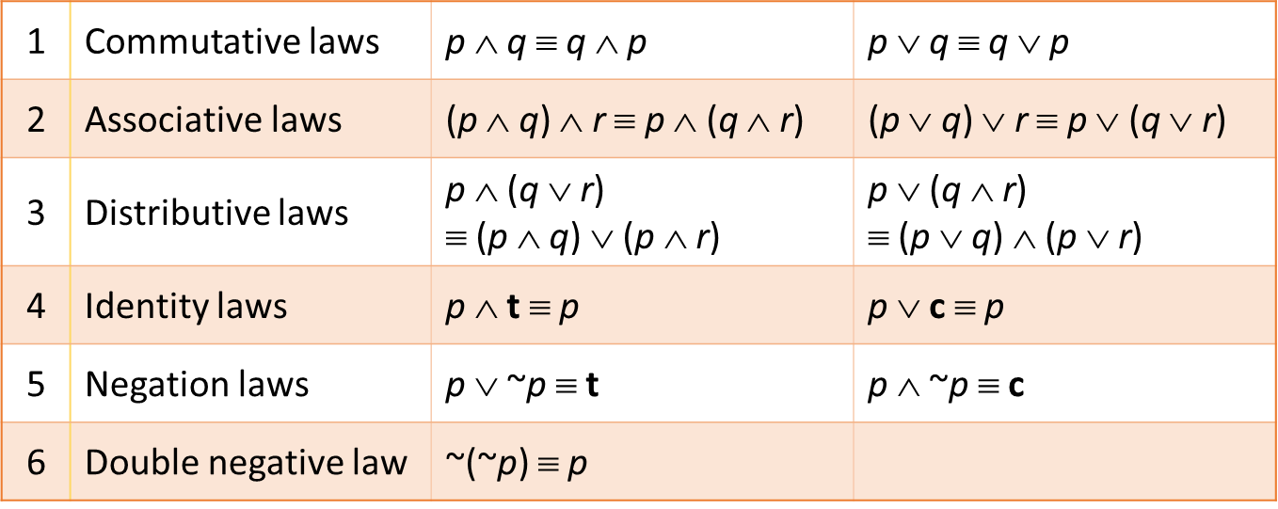

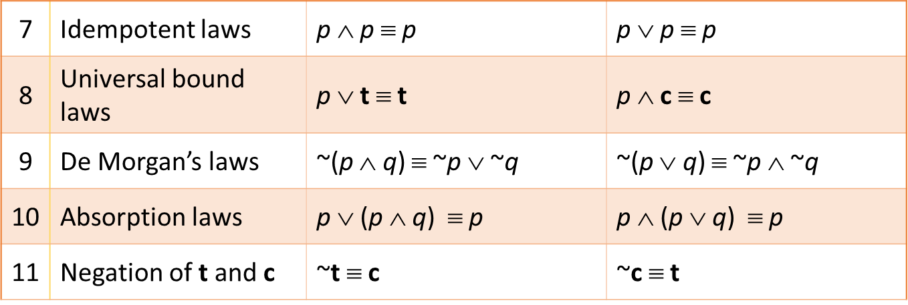

Importance of Operations:

NOT>(AND=OR)>(IMPLIES==IF AND ONLY IF (BICONDITIONAL))

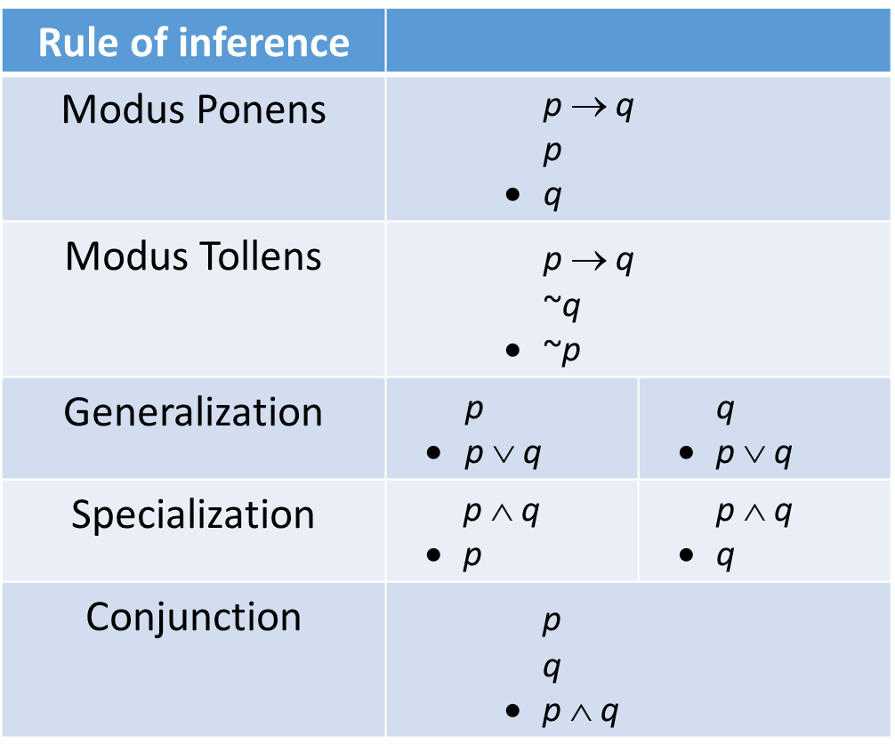Valid and Invalid Arguments:

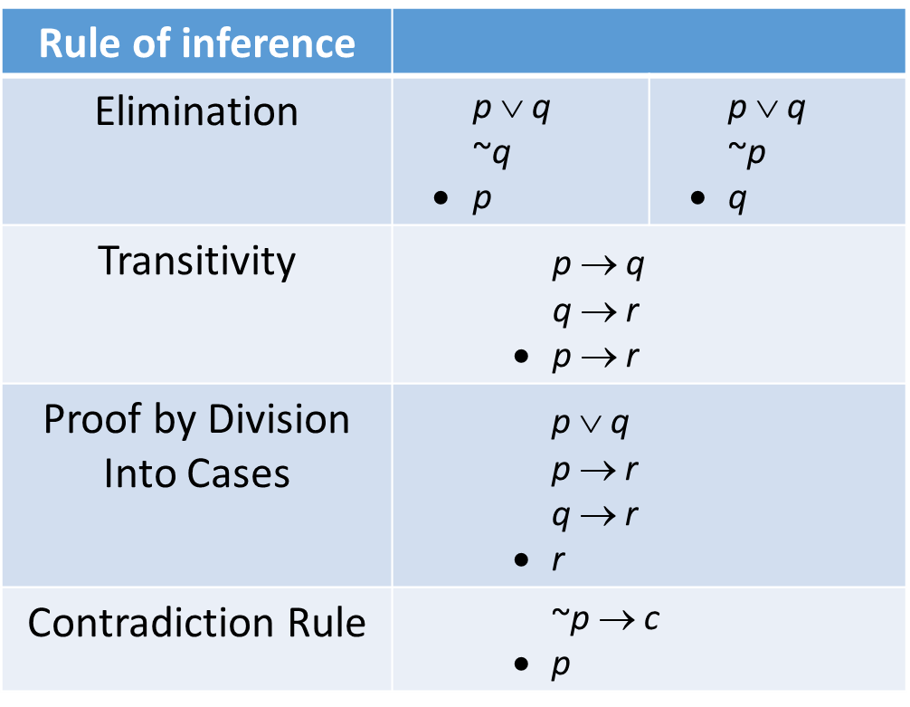

**DEFINITIONS:**

**Divisibility (Definiton 1.3.1):**

**If n and d are integers and d≠ 0**

n is divisible by d iff n equals d times some integer

i.e. $d|n⇔∃ integer k such that n=dk and d≠0$

**Even and Odd Numbers (Definition 1.6.1):**

An integer as even iff it is twice some other integer. It is odd iff it is twice some other integer+1

$n is even⇔∃ integer k such that n=2k$

$n is odd⇔∃ integer k such that n=2k+1$

**Prime Numbers (Definition 4.2.1):**

An integer n is prime or composite according to the following:

$n is prime⇔n>1 and ∀ r,s∈Z^{+}, if n=rs then \left(r=1 and s=n\right) OR \left(r=n and s=1\right)$ $n is composite⇔n>1 and ∃ r,s∈Z^{+} such that n=rs and 1<r,s<n$

**Lower Bound:**

$An integer b is said to be a lower bound for a set X⊆Z if b≤x, ∀x∈X$

**Greatest Common Divisor (Definition 4.5.1):**

$Let a and b not both zero integers.$ $The greatest common divisor of a and b\left(denoted\gcd\left(a,b\right)\right), is the integer d which satisfies the following$

$\left(i\right)d\left|a and d\right|b and \left(ii\right)∀c∈Z if c\left|a and c\right|b then c≤d$]

**Co-prime (Definition 4.5.3):**

$Integers a and b are co-prime⇔\gcd\left(a,b\right)=1$

**Least Common Multiple (Definition 4.6.1):**

$An integer m=lcm\left(a,b\right)where a,b are not both zero is defined such that$

$\left(i\right)a\left|m and b\right|m \left(ii\right)for all integers c, if a\left|c and b\right|c then m≤c.$

**Modular congruence (Definition 4.7.1):**

$$Let m\&n be integers, and let d be a positive integer. We say that m is congruent to n modulo d and write$$

$m≡n\left(mod d\right),$ $if and only if d|(m-n)$

**Multiplicative inverse modulo n (Definition 4.7.2):**

$$For any integers a,n with n>1, if an integer s is such that as≡1 \left(mod n\right),$$

$then s is called the multiplicative inverse of a modulo n.$ $We may write it as a^{-1}. Also note that a^{-1}a≡1 \left(mod n\right) due to commutativity$

**Second-order Linear Homogeneous Recurrence Relation with Constant Co-efficients:**

$$The above is defined as a recurrence relation with the form:$$

$$a_{k}=Aa_{k-1}+Ba_{k-2}, ∀k∈Z_{≥k_{0}},$$

$$where A,B are real constants and B≠0 and k_{0} is an integer constant$$

**Set Theory Definitions:**

**Empty Set (Definition 6.3.1):**

$$The empty set has no element and is denoted by ϕ or \left\{ \right\}.$$

**Set Equality (Definition 6.3.2):**

$$Two sets are equal iff they have the same elements:$$

$$i.e. ∀X∀Y((∀Z\left(Z∈X⟷Z∈Y\right))⟷X=Y)$$

**Power Set (Definition 6.3.4):**

$$Given any set S, the power set of S denoted as P\left(S\right) or 2^{s}, is the set whose elements are all subsets of$$

$$the set S, nothing less and nothing more.$$

$$i.e. If T=P\left(S\right), then ∀X((X∈T)⟷(X⊆S))$$

**Union (Definition 6.4.1):**

$$Let S be a set of sets. We say T is the union of all sets in S iff each element in T belongs to some set in S$$

$$nothing less, nothing more. We write it as such:$$

$$T=\bigcup{S}=\bigcup_{X∈S}{X} such that ∀Y\left(\left(Y∈T\right)⟷∃Z\left(\left(Z∈S\right)⋀\left(Y∈Z\right)\right)\right)$$

**Intersection (Definition 6.4.3):**

$$Let S be the set of nonempty sets. We say T is the intersection of all sets in S iff each element in T$$

$$belongs to all the sets in S, nothing less, nothing more. We write it as such:$$

$$T=\bigcap{S}=\bigcap_{X∈S}{X such that ∀Y(\left(Y∈T\right)↔∀Z\left(\left(Z∈S\right)→\left(Y∈Z\right)\right))}$$

**Disjoint Sets (Definition 6.4.5):**

$$Two sets S and T are disjoint iff S⋂T=ϕ$$

**Mutually Disjoint (Definition 6.4.6):**

$$Let V be a set of sets. The sets T∈V are said to be mutually disjoint iff:$$

$$∀X,Y∈V\left(X≠Y→X⋂Y=ϕ\right)$$

**Partition (Definition 6.4.7):**

$$Let S be set , and let V be a set of nonempty subsets of S. V is partition iff:$$

$$\left(i\right)V is mutually disjoint and \left(ii\right)\bigcup{V=S}$$

**Non-symmetric difference (A-B) (Definition 6.4.8):**

$$A-B is defined as elements that are in A but not in B, nothing less nothing more.$$

$$i.e. ∀X\left(X∈\left(A-B\right)↔\left(X∈A⋀X∉B\right)\right)$$

**Symmetric-Difference (Definition 6.4.9):**

$$The symmetric difference \left(A⊖B\right)is defined as elements that are in A or in B but not both$$

$$∀X\left(X∈\left(A⊖B\right)↔\left(\left(X∈A\right)⊕\left(X∈B\right)\right)\right)$$

**Complement (Definition 6.4.10):**

$$Let U be the Universal Set where A⊆U. Then the complement A^{c}, is U-A$$

**Cartesian product (Definition 8.1.3 &8.1.4 (general)):**

$$Let S and T be two sets. Their Cartesian product, written as S×T is defined as:$$

$∀X∀Y\left(\left(X,Y\right)∈S×T↔\left(X∈S⋀Y∈T\right)\right). It is not commutative or associative.$

$Generalizing for n sets it can be represented as the sets S in V :$

$$\prod_{S∈V}{S}$$

**Relation (Definition 8.2.1 & 8.2.7(generalized))**

$$For any two sets S and T, a binary relation R from S to T is subset of S×T. Therefore:$$

$$x R y→\left(x,y\right)∈S×T$$

$$x R y→\left(x,y\right)∉S×T$$

$$Can be generalized to n-ary relation, where n is the arity/degree of the relation$$

**Domain, Range, Co-domain (Definition 8.2.2 to 8.2.4):**

$$For any binary relation from S to T:$$

$$Domain=\left\{s∈S | ∃t∈T\left(s R t\right)\right\}, Codomain=T, Range/Image=\left\{t∈T | ∃s∈S\left(s R t\right)\right\}$$

$Therefore Range⊆Codomain$ (**Proposition 8.2.5)**

**Inverse Relation (Definition 8.2.6):**

$$The inverse relation R^{-1} from T to S is such that:$$

$∀s∈S, ∀t∈T(t R^{-1} s↔s R$ t)

**Composition (Definition 8.2.9):**

$$For the three sets S,T \&U, let a relation R be from S to T and a relation R^{'}be from T to U.$$

$$The composition of that relation R^{'}∘R is such that R^{'}∘R⊆S×U and:$$

$$∀x∈S, ∀z∈U(x{ R}^{'}∘R z↔\left(∃y∈T\left(\left(x R y\right)⋀\left(y R z\right)\right)\right)$$

**Reflexivity, Symmetry and Transitivity of Relations (8.3.1 to 8.3.3):**

$$The following are used to describe relations on a set A and itself:$$

$$(8.3.1)Reflexive:∀x∈A\left(x R x\right)↔R is reflexive.$$

$$Irreflexive:R is irreflexive ∀x∈A (x R x)$$

$$(8.3.2)Symmetric:R is symmetric↔∀x, y∈A\left(x R y→y R x\right)$$

$$(8.6.1)Anti-symmetric:R is anti-symmetric↔∀x,y∈A\left(x R y⋀yRx→x=y\right)$$

$$Asymmetric:R is asymmetric↔∀x,y∈A\left(x R y→yR x\right)$$

$$i.e. R is antisymmetric and irreflexive$$

(8.3.3) $Transitive:R is transitive↔∀x,y,z∈A ((x R y⋀y R z)→x R z$)

**Definition 8.3.4 (Equivalence Relation):**

$$If a relation R on A is reflexive, transitive and symmetric, R is said to be an equivalence relation$$

**Definition 8.3.5 (Equivalence Class):**

$$Let R be an equivalence relation$$

$$Let x∈A. The equivalence class of x , denoted as \left[x\right], is the set of all y∈A such that x R y:$$

$$i.e. \left[x\right]=\{y∈A|x R y\}$$

**Definition 8.5.1 (Transitive Closure):**

$$Let R be a relation on set A. The transitive closure of R, denoted as R^{t}, is a relation that satisfies the$$

$$the following:$$

$$\left(1\right)It is transitive, \left(2\right)R⊆R^{t}, \left(3\right)For any transitive relation S on A, where R⊆S, R^{t}⊆S$$

**Definition 8.6.2 (Partial Order):**

$$R is said to be a partial order iff it is reflexive, antisymmetric and transitive. Partial orders are$$

$$denoted by \text{≼}. A is poset if≼is a partial order relation on A.$$

**Definition 8.6.3 (Comparable):**

$$Let≼be partial order relation on A. For a,b∈A are said to be comparable iff a≼b$$

$$or b≼a. If no such relation exists between a and b, the are said to be noncomparable$$

**Definition 8.6.4 (Total Order):**

$$If≼is a partial order on set A, ≼is a total order iff:$$

$$∀a,b∈A\left(a≼b ⋁b≼a\right). i.e. All elements in A are comparable to each other$$

**Definitions 8.6.5-8.6.8 (Minimax definitions):**

$$8.6.5 Maximal:An element b∈A is said to be maximal element iff ∀c∈A\left(b≼c→b=c\right)$$

$$8.6.7 Minimal:An element a∈A is a minimal element iff ∀b∈A\left(b≼a→b=a\right)$$

$$\left(Note vacuous truth for non comaparable elements. Same hold for maximal\right)$$

$$8.6.6 Maximum:An element ⊤∈A is said to be the maximum iff ∀y∈A \left(y≼⊤\right)$$

$$8.6.8 Minimum:An element⊥∈A is said to be the minimum iff ∀y∈A\left(⊥≼y\right)$$

$$\left(Note minimum/maximum requires≼to be a total order\right)$$

**Definition 8.6.9.**

$$Let≼ be a total order on A. Iff every nonempty subset of A contains a minimum element,$$

$$A is said to be well ordered. Formally:∀S∈P(A)(S≠ϕ→(∃x∈S(∀y∈S\left(x≼y\right))))$$

**Definition 7.1.1 (Function):**

$$Let f be a relation from S to T. f is a function from S to T iff ∀x∈S\left( ∃!y∈T \left(x f y\right)\right)$$

**Definition 7.1.2-7.1.5:**

$$Let f be a function from S to T$$

$$7.1.2 x is the pre-image for y if f\left(x\right)=y$$

$$7.1.3 The inverse image of y=\left\{x∈S | f\left(x\right)=y\right\}$$

$$7.1.4 For any U⊆T, the inverse image of U is the set of all inverse images of y∈U.$$

$$7.1.5 The restriction of f to U⊆S is the set :\left\{ \left(x,y\right)∈U×T | f\left(x\right)=y\right\}$$

**Definition 7.2.1-7.2.3(Injective, Surjective, Bijective, Identity):**

$7.2.1 Let f be a function from S to T. f is injective$/ $f is one$- $to$- $one$/ $f is an injection iff:$

$$∀y∈T , ∀x_{1},x_{2}∈S(\left(f\left(x_{1}\right)=y⋀f\left(x_{2}\right)=y\right)→ x_{1}=x_{2}$$

$7.2.2 Let f be a fucntion from S to T. f is surjective$/ $f is onto$/ $f is a surjection iff:$

$$∀y∈T, ∃∈S\left(f\left(x\right)=y\right)$$

$$7.2.3 A function is bijective iff it is injective and surjective. We call such an f a bijection$$

$$7.3.2 The identity function \left(I_{A}\right) on A from A is defined as ∀x∈A(I_{A}\left(x\right)=x)$$

**Counting and Probability:**

**Sample Space:**

$$A sample space, S is the set of all possible event outcomes of a random process or experiment.$$

$$An event, E is the susbet of the sampel space.$$

**Probability:**

$$For a finite sample space, S in which all outcomes are equally likely and E is an event in S, then$$

$$the probability of E occurring is :P\left(E\right)=\frac{The number of outcomes in in E}{The number outcomes in S}=\frac{N\left(E\right)}{N(S)}$$

**r-Combinations:**

**Let *n* and *r* be non-negative integers with *r* ≤ *n*.**

**An *r*-combination of a set of *n* elements is a subset of *r* of the *n* elements.**

**Expected Value:**

$$Suppose events a_{1},a_{2},a_{3}..a_{k} occur with probabilities p_{1},p_{2},p_{3}..p_{k}. Then the expected value of$$

$$of this process is: \sum_{i=1}^{k}{a_{i}⋅p_{i}}$$

**Conditional probability:**

$$Given two events A and B in sample space S. If P\left(A\right)≠0, then conditional probability$$

$$of B given A, written as P\left(B | A\right)=\frac{P\left(A⋂B\right)}{P\left(A\right)}$$

**Independent Events:**

$$If A and B are events in a sample space S, then A and B are independent iff:$$

$$P\left(A⋂B\right)=P\left(A\right).P\left(B\right)$$

**Pairwise Independent:**

$$Events A, B and C in a sample space S are pairwise independent, if 1-3 are satisfied.$$

$$If 4 is satisfied, they are said to be mutually independent.$$

$$1. P\left(A⋂B\right)=P\left(A\right)⋅P\left(B\right),$$

$$2. P\left(A⋂C\right)=P\left(A\right)⋅P\left(C\right),$$

$$3. P\left(B⋂C\right)=P\left(B\right)⋅P\left(C\right),$$

$$4. P\left(A⋂B⋂C\right)=P\left(A\right)⋅P\left(B\right)⋅P\left(C\right)$$

$$Note:Pairwise and mutual independence are unrelated. One doesn^{'}timply the other.$$

**GRAPH THEORY:**

**Graph:**

$$A graph G consists of two finite sets:A nonempty set of vertices V\left(G\right) and a set of edges E\left(G\right),$$

$$where each edge is associated with two vertices called its endpoints.$$

$$If an edge connects 2 vertices, they are said to be adjacent, even if it is a self loop.$$

$$Edges incident on the same endpoint are said to be adjacent as well. An edge e with endpoints$$

$$v and w are represented as given:e=\left\{v,w\right\}$$

$$Directed:If a graph G is directed, the edges set is now a set of ordered pairs D\left(G\right). If the edges$$

$$goes from v to w, the directed edge is represented as e=\left(v,w\right)$$

$$Simple:A simple grpah has no parallel edges or self loops$$

$$Complete:A complete graph with n vertices, is a simle graph where each vertex is adjacent to an$$

$$other vertex in the vertex set.$$

$$Complete Bipartite:A bipartite graph , denoted K_{m,n},is a complete graph with two disjoint vertex sets$$

$$of m and n vertices respectively. Note that there will be no edge connecting two vertices of the same set$$

$$but there will be one edge between each and every vertex in set 1 to every vertex in set 2$$

$$Subgraph:A graph H is said to be subgraph iff every vertex in H is in G, every edge in H is in G and$$

$$each edge in H has the same endpoint as the same edge in G.$$

$$Connected Graph:A graph is connected iff given any two vertices v and w in G, there will be a walk$$

$$from v to w along the edges in G. i.e. ∀v,w∈V\left(G\right) ∃ a walk P from v to w$$

**Degree:**

$$The degree of a vertex is the number of edges incident on that vertex in the graph G. Note$$

$$that self-loops are counted twice. The total degree of the graph is the sum of all the$$

$$degrees of each vertex in G$$

**Trails, Walks, Paths, Circuits, Closed walks, closed circuits, Simple circuits:**

$$Let G be a graph and let v and w be any two vertices in G.$$

$$Walk:A finite alternating sequence of adjacent vertices and edges of g from v to w.$$

$$A walk is usually written as v_{0}e_{0}v_{1}e_{2}…v_{k}. A walk to itself(one vertex only) is considered trivial.$$

$$Trail:A walk from v to w without repeating edges$$

$$Path:A walk from v to w without repating edges or vertexes$$

$$Closed Walk:A walk from vertex v to itself$$

$$Circuit:A closed walk that does have repeated edges$$

$$Simple Circuit:A circuit that is path with only the endpoints being repeated$$

$$Connected:Two vertices v and w are connected iff there is a walk from v to w$$

$$Connected component:A graph H is called a a connected component of G iff$$

$$1. H is a subgraph of G, 2.H is connected, 3. No larger subgraph has edges or vertices that are not in H$$

$$Euler circuit:A circuit in G that contains every vertex and edge in G . Vertices can be repeated.$$

$$Euler trail:A trail in G that contains every vertex and edge in G. Vertices can be repeated.$$

$$Hamiltonian circuit:A simple circuit containing every vertex in G.$$

**Isomorphic Graph:**

$Two graphs G and G^{'}are isomorphic to itself iff there exists a one$- $to$- $one correspondence between V\left(G\right)→V\left(G^{'}\right)and E\left(G\right)→E\left(G^{'}\right) that preserve edge endpoint$

$$functions. preserve of both graphs for all v∈V\left(G\right),V\left(G^{'}\right) and e∈E\left(G\right), E\left(G^{'}\right).$$

**Trees:**

$$A graph is a tree iff it is connected and is circuit free. If it is not connected it is called a forest$$

$A tree with one vertex is a trivial tree.$

A **weighted graph** is a graph for which each edge has an associated positive real number **weight** . The sum of the weights of all the edges is the **total weight** of the graph.

A **minimum spanning tree** for a connected weighted graph is a spanning tree that has the least possible total weight compared to all other spanning trees for the graph.

If *G* is a weighted graph and *e* is an edge of *G*, then ***w*(*e*)** denotes the weight of *e* and ***w*(*G*)** denotes the total weight of *G*

**Theorems:**

**Theorem 4.1.1:**

$∀a,b,c∈Z, if a\left|b and a\right|c, then ∀x,y∈Z, a|(bx+cy)$

**Proposition 4.2.2:**

$For any two primes p and p^{'}if p|p^{'}then p=p^{'}$

**Theorem 4.2.3:**

$If p is a prime and x_{1}, x_{2},…, x_{n}$*are any integers such that p |*

**Theorem 4.3.1 (Epp):**

$∀a,b∈Z^{+}, if a|b then a≤b$

**Theorem 4.3.3 (Epp)**:

$∀a,b,c∈Z, if a\left|b and b\right|c, then a|c$

**Theorem 4.3.4 (Epp):**

$Any integer n>1 is divisible by a prime number$

**Theorem 4.3.5 (Epp):**

$Given any integer n>1, There exist a positive integer k, distinct prime numbers p_{1},p_{2},…p_{k } and positive integers e_{1},e_{2}…e_{k } such that$

$$n=p_{1}^{e_{1}}×p_{2}^{e_{2}}×…×p_{k}^{e_{k}}$$

$and any other expression for n as a product of its prime factors will be identical$

**Proposition 4.7.3 (Epp):**

$For any a∈Z and any prime p, if p|a then p∤(a+1)$

**Theorem 4.7.4 (Epp):**

$The set of primes is infinite$

**Theorem 4.3.2 (Well Ordering Principle):**

$If a nonempty subset S⊆Z has a lower bound then S has a least element \left(minimum\right).$ $Similarly if the same subset S has an upper bound then S has a most element\left(maximum\right)$

**Proposition 4.3.3:**

$If a set S has a least element, its least element is unique$

**Theorem 4.4.1 (Quotient Remainder Theorem): $Given any integer a and any positive integer b, there exists unique integers q and r such that$**

$$a=bq+r, 0≤r<b$$

**Theorem 4.5.2(Bezout’s Identity):**

$Let a and b be integers where at ost one among a and b can be zero. Let d=\gcd\left(a,b\right).$

$$Then there exists x,y∈Z such that ax+by=d. Note that this identity is non- unique.$$

**Proposition 4.5.4**

$For any integers a,b both nonzero if c\left|a and c\right|b then c|gcd⁡(a,b)$

**Theorem 8.4.1 (Epp) (Modular Equivalences)**

$Let a,b and n be integers where n>1. The following statements are equivalent:$

$$1.n|\left(a-b\right)$$

$$2.a≡b\left(mod n\right)$$

$$3.a=b+kn for some k∈Z$$

$$4. a and b have the same remainder when divided by n$$

$$5. a\left(mod n\right)=b(mod n)$$

**Theorem 8.4.3 (Epp):**

$Let a,b,c,d and n be integers where n>1 and suppose$

$1. a≡c \left(mod n\right) and 2. b≡d\left(mod n\right).$

$$Then the following are equivalent:$$

$$1. \left(a±b\right)≡\left(c±d\right) \left(mod n\right)$$

$$2. ab≡cd \left(mod n\right)$$

$$3. a^{m}≡c^{m}\left(mod n\right), for positive integers m$$

**Corollary 8.4.4 (Epp):**

$$Let a,b,n be integers with n>1. Then,$$

$$ab≡\left[\left(a mod n\right)\left(b mod n\right)\right]\left(mod n\right) (i.e. ab mod n=\left(a mod n\right)\left(b mod n\right) mod n$$

$$Consequently, a^{m}≡\left[{\left(a mod n\right)}^{m}\right] \left(mod n\right)$$

**Theorem 4.7.3 (Existence of Multiplicative Inverse)**

$$For any integer a, its multiplicative inverse modulo n \left(where n>1\right){, a}^{-1}, exists if and only$$

$$if a and n are coprime$$

**Corollary 4.7.4 (Special case: n is prime):**

$$If n=p is a prime number, then all integers in the range 0<a<p have multiplicative$$

$$inverses modulo p.$$

**Theorem 8.4.9 (Epp)**

$$For all integers a,b,c,n with n>1 and a and n are coprime,$$

$$if ab≡ac \left(mod n\right), then b≡c \left(mod n\right)$$

**Theorem 5.1.1 (Epp)**

$$For any sequences of real numbers a_{m},a_{m+1}…a_{n} and b_{m}, b_{m+1},…b_{n}, the following equations are valid$$

$$for any ,m≤n and c∈R$$

$$1. \sum_{k=m}^{n}{a_{k}}+ \sum_{k=m}^{n}{b_{k}= \sum_{k=m}^{n}{{(a}_{k}+b_{k})}}$$

$$2.c\left(\sum_{k=m}^{n}{a_{k}}\right)=\sum_{k=m}^{n}{{(c⋅a}_{k})}$$

$$3.\left(\prod_{k=m}^{n}{a_{k}}\right)⋅\left(\prod_{k=m}^{n}{b_{k}}\right)=\prod_{k=m}^{n}{{(a}_{k}⋅b_{k})}$$

**Theorem 5.8.3(Epp) Distinct Roots Theorem:**

$$Suppose a sequence a_{0},a_{1}, a_{2}…satisfies the SLHRCC. If the characteristic eqn of$$

$$t^{2}-At-B has two distinct roots, then the explicit formula for a_{n} can be denoted as :$$

$$a_{n}=Cr^{n}+Ds^{n}, ∀n∈Z$$

$where r and s are the roots of the characteristic equation and C and D$ $are constants determined by the initial conditions a_{0} and a_{1}$

**Theorem 5.8.5(Epp) $Suppose a sequence a_{0},a_{1}, a_{2}…satisfies the SLHRCC. If the characteristic eqn of$**

$$t^{2}-At-B has only one real root, then the explicit formula for a_{n} can be denoted as :$$

$$a_{n}=Cr^{n}+D{nr}^{n} , ∀n∈Z$$

$where r is the real root of the characteristic equation and C and D$ $are constants determined by the initial conditions a_{0} and a_{1}$

**Theorem 6.2.1 (Epp):**

$$For all sets A,B and C$$

$1. A⋂B⊆A and$ $A⋂B⊆B, 2. A⊆A⋃B and B⊆A⋃B, 3. A⊆B and B⊆C, then A⊆C$

**Theorem 6.2.2 (Epp):**

$$For all sets, A ,B and C:$$

$$Same as tables regarding logical equivalences \left(⋃by OR and⋂ by AND, 1≡U and ϕ≡0\right).$$

$$With the addition of set difference where A-B=A⋂B^{c}$$

**Theorem 6.2.3 (Epp):**

$$Under proposition 6.4.4 and 6.4.2$$

**Theorem 6.2.4 (Epp):**

$$The empty set is the subset of all sets$$

**Proposition 6.3.3 & Corollary 6.2.5(Epp):**

$$For any two sets X and Y, X⊆Y⋀Y⊆X iff X=Y. Corollary:The empty set is unique.$$

**Proposition 6.4.2:**

$Let A,B and C be sets,$ then

$$\bigcup{ϕ=}\bigcup_{A∈ϕ}{ }→A=ϕ and\bigcup{\left\{A\right\}=A}$$

$$A⋃ϕ=A, A⋃B=B⋃A, \left(A⋃B\right)⋃C=A⋃\left(B⋃C\right),A⋃A=A and A⊆B↔A⋃B=B$$

**Proposition 6.4.4:**

$Let A,B and C be sets,$ then

$$A⋂ϕ=ϕ, A⋂B=B⋂A, A⋂\left(B⋂C\right)=\left(A⋂B\right)⋂C,A⊆B↔A⋂B=A$$

$$Distributivity laws:A⋂\left(B⋃C\right)=\left(A⋂B\right)⋃\left(A⋂C\right), A⋃\left(B⋂C\right)=\left(A⋃B\right)⋂\left(A⋃C\right)$$

**Proposition 8.2.9 and 8.2.10:**

$$8.2.9. Composition is associative. 8.2.10 And its inverse is such that:{\left(R∘R^{'}\right)}^{-1}=R^{'-1}∘R^{-1}$$

**Theorem 8.3.1**

$$Any partition of a set can be represented by an equivalence relation whose equivalence classes make$$

$$up the sets in the partition.$$

**Lemma 8.3.2 &8.3.3 (Epp):**

$$Given an equivalence relation R on A, and where a,b∈A, a R b→\left[a\right]=\left[b\right]. (8.3.2)$$

$$Similarly if a R b→\left[a\right]⋂\left[b\right]=ϕ. So \left[a\right]=\left[b\right] or \left[a\right]⋂\left[b\right]=ϕ (8.3.3)$$

**Theorem 8.3.4 (Epp):**

$$Any equivalence relation R on set A will form a partition of set A by its distinct equivalence classes$$

**Proposition 8.5.2:**

$$The transitive closure of a relation R can be obtianed by the union of repeated compositions of R$$

$$i.e R^{t}=\bigcup_{i=1}^{∞}{R^{i}}$$

**Proposition 7.2.4 (Existence of $f^{-1}$)**

$$Let f be a function from S to T. Then f^{-1} is the inverse relation from T to S. f^{-1} is a fucntion iff$$

$$f is bijective.$$

**Proposition 7.3.1 (Composition):**

$$Let f be a function from S to T, and g be a fucntion from T to U. Then the compostion of$$

$$g∘f from S to U and f∘g from U to S are also functions.$$

**Proposition 7.3.3**

$$Let f:A→A be an injective function. Then f∘f^{-1} is the identity function.$$

$${(f}^{-1}∘f=identity also if f is bijective)$$

**Theorem 9.1.1:**

$$If m and n are integers and m≤n, then there are x= n-m+1 integers from m to n$$

$inclusive of m and n.$

**Theorem 9.2.1 (The Multiplication Rule):**

$$If an operation consists of k steps and each step i can be perfomed in n_{i }number of ways, independent$$

$$of the number of steps preceding step i the total number of the ways to complete the operation will be$$

$$Number of ways=\prod_{i=1}^{k}{n_{i}}$$

**Theorem 9.2.2 (Permutations of n objects):**

$$The number of permutations of a set with n \left(n≥1\right) elements is n!$$

**Theorem 9.2.3 r-Permutations from a set of n elements**

$$The number of r-permutations from a set of n elements is given by the formula$$

$$P\left(n, r\right)=\frac{n!}{\left(n-r\right)!} where 1≤r≤n$$

**Theorem 9.3.1 The Addition Rule**

$$Suppose a finite set A is equivalent tot he union of k distinct mutually disjoint subsets A_{1},A_{2},…A_{k}.$$

$$Then, N\left(A\right)=N\left(A_{1}\right)+N\left(A_{2}\right)+…{N(A}_{k})$$

**Theorem 9.3.2 The Difference Rule**

$$The A is a finite set and B is a subset of A, then N\left(A-B\right)=N\left(A\right)-N\left(B\right)$$

**Theorem 9.3.3 The Inclusion-Exclusion Principle**

$$If A,B and C are finite sets , then the following hold true:$$

$$N\left(A⋃B\right)=N\left(A\right)+N\left(B\right)-N\left(A⋂B\right), and$$

$$N\left(A⋃B⋃C\right)=N\left(A\right)+N\left(B\right)+N\left(C\right)-N\left(A⋂B\right)-N\left(A⋂C\right)-N\left(B⋂C\right)+N\left(A⋂B⋂C\right)$$

**Generalized Pigeonhole Principle (Contrapositive):**

*For any function f from a finite set X with n elements to a finite set Y with m elements and for any positive integer k, if k < n/m, then there is some y ∈ Y such that y is the image of at least k + 1 distinct elements of X.*

*For any function f from a finite set X with n elements to a finite set Y with m elements and for any positive integer k, if for each y ∈ Y, f –1(y) has at most k elements, then X has at most km elements; in other words, n ≤ km.*

**Theorem 9.4.2**

$If f is a function from X to Y, where X and Y are finite, f is on one$- $to$- $one iff f is onto$

**Theorem 9.5.1**

$$\left({n \atop r}\right)=\frac{P\left(n,r\right)}{r!}=\frac{n!}{\left(n-r\right)!(r!)}$$

**Theorem 9.5.2**

$$The number of ways to permute a collection of n objects with n distinguishable sets$$

$$is \frac{n!}{n_{1}!n_{2}!n_{3}!n_{4}!..n_{k}!}$$

**Theorem 9.6.1**

$$The number of r-combinations with repetition that can be selected from n elements is$$

$$\left({n+r-1 \atop r}\right)$$

**Pascal’s Formula(Theorem 9.7.1):**

$$\left({n+1 \atop r}\right)=\left({n \atop r}\right)+\left({n \atop r-1}\right)$$

**Binomial Theorem (Theorem 9.7.2):**

$${\left(a+b\right)}^{n}=\sum_{k=0}^{n}{\left({n \atop k}\right)a^{n-k}b^{k}}$$

**Probability Axioms:**

$$1. 0≤P\left(A\right)≤1,$$

$$2. P\left(ϕ\right)=0,$$

$$3. If A and B are disjoint \left(A⋂B=ϕ\right), then P\left(A⋃B\right)=P\left(A\right)+P\left(B\right)$$

**Theorem 9.9.1-9.9.3:**

$$9.9.1 P\left(B | A\right)=\frac{P\left(A⋂B\right)}{P(A)}$$

$$9.9.2 P\left(A⋂B\right)=P\left(B | A\right).P\left(A\right)$$

$$9.9.3 P\left(A\right)=\frac{P(A⋂B)}{P(B|A)}$$

**Bayes’ Theorem:**

$$Suppose S is a sample space with n disjoint events B_{1}-B_{n}. Suppose A is an event in S$$

$$and assume P\left(A\right), P\left(B_{i}\right)≠0 where 0≤i≤n. Then for any particular i:$$

$$P\left(B_{i} | A\right)=\frac{P\left(A | B_{i}\right). P(B_{i})}{P\left(A | B_{1}\right).P\left(B_{1}\right)+P\left(A | B_{2}\right).P\left(B_{2}\right)+…P\left(A | B_{n}\right).P(B_{n})}$$

**Theorem 10.1.1 (Handshake Theorem):**

$$A graph G with n edges has a total degree of 2n. i.e. \sum_{i=1}^{n}{\deg\left(v_{i}\right)=2n, where v_{i}∈G}$$

$$P\left(A⋂B\right)=P\left(A\right)⋅P(B)$$

**Corollary 10.1.2:**

$$The total degree of a graph is always even$$

**Propostition 10.1.3:**

$$In any graph there are an even number of vertices of an odd degree.$$

**Lemma 10.2.1:**

$$Let G be a graph.$$

$$\left(a\right)If G is connected then there is a path between any two vertices$$

$$\left(b\right)If v and w vertices are part of a circuit in G, and one edge is removed, there exists a trail$$

$$between v and w$$

$$\left(c\right)If G is connected and G contains a circuit, then an edge of the circuit can be removed$$

$$without disconnecting G$$

**Theorem 10.2.2:**

$$If a graph has an Euler circuit, every vertex in the graph has an even degree. If there exists$$

$$any vertex with an odd degree, no Euler cirucit exits in that graph$$

**Theorem 10.2.3:**

$$Given a graph G is connected and all vertices have a positive even degree, then it has an Euler$$

$$circuit.$$

**Theorem 10.2.4:**

$$Graph G has an Euler circuit iff G is connected and every vertex in G has an even degree$$

**Corollary 10.2.5:**

$$Let G be a graph, and let v and w be two distinct vertices of G. Then there is an euler trail from$$

$$v to w if v and w have odd degrees and the rest of the vertices in G have a positive even degree$$

**Proposition 10.2.6**

$$If a graph G has a Hamiltonian circuit, then G has subgraph H with the following properties:$$

$$1. H contains every vertex of G, 2. H is connected, 3. H has has the same number of edges as$$

$$vertices, 4. Every vertex of H has degree 2$$

**Adjacency Matrices:**

$$If a vertex i is adjacent to vertex j and there are k edges from i to j, then m_{ij}=k. Also,$$

$$in an undirected grpah, its adjacency matrix is always symmetric. An adjacency matrix A$$

$$of a graph G displays the walks from i to j of length 1 at the entry m_{ij}. Subsequent powers of n$$

$will give the walks of length n from i to j at the i,j^{th} entry.$ (Theorem 10.3.2)

**Theorem 10.4.1 (Isomorphism)**

$$If S is a set of grpahs and R be the relation of grpah isomorphism on S. Then R is an equivalence$$

$$relation on S$$

**Theorem 10.4.2 Graph Isomorphism invariants:**

$$If two graphs G and G^{'} are isomorphic then the following hold true:$$

$$1. Both have n vertices$$

$$2. Both have m edges$$

$$3. Both have vertex of degree k, if exists in G$$

$$4. Both have m vertices of degree k if exists in G$$

$$5. Both have a circuit of length k, if exists in G$$

$$6. If G has a simple cirucit of length k, G^{'}has it too$$

$$7. Has m simple circuits of length k, if exists in G$$

$$8. If G is connected, so is G^{'}$$

$$9. If G has an Euler circuit, so does G^{'}$$

$$10. If G has a Hamiltonian circuit, so does G^{'}$$

**Lemma 10.5.1:**

$$Any nontrivial tree has at least one vertex of degree one$$

**Theorem 10.5.2:**

$$Any nontrivial tree with n vertices has n-1 edges$$

**Lemma 10.5.3:**

$$If G is a connected graph , C is any circuit in G , and one of the edges of C is removed from G,$$

$$then the graph remains connected$$

**Theorem 10.5.4:**

$$A graph with n vertices and n-1 edges is a tree$$

**Theorem 10.6.1: Full Binary Tree**

$$If T is a full binary tree with k internal vertices , then T has a total of 2k+1 vertices$$

$$and has k+1 terminal vertices$$

**Theorem 10.6.2**

$$For non-negative integers h, if T is a binary tree with height h and t terminal vertices,$$

$$then t≤2^{h}, i.e.\log_{2}{t}≤h$$

**Proposition 10.7.1**

$$Every connected graph has a spanning tree. Any two spanning trees have the same number of edges.$$

$$A spanning tree for a graph G is a subgraph which is a tree and contains every vertex in G$$

F1. *Commutative Laws* For all real numbers *a* and *b*,  
*a* + *b* = *b* + *a* and *ab* = *ba.*  
F2. *Associative Laws* For all real numbers *a, b,* and *c,*  
*(a* + *b)* + *c* = *a* + *(b* + *c)* and *(ab)c* = *a(bc).*  
F3. *Distributive Laws* For all real numbers *a, b,* and *c,*  
*a(b* + *c)* = *ab* + *ac* and *(b* + *c)a* = *ba* + *ca.*  
F4. *Existence of Identity Elements* There exist two distinct real numbers, denoted 0  
and 1, such that for every real number *a,*  
0 + *a* = *a* + 0 = *a* and 1 · *a* = *a* · 1 = *a.*  
F5. *Existence of Additive Inverses* For every real number *a*, there is a real number,  
denoted −*a* and called the **additive inverse** of *a,* such that  
*a* + *(*−*a)* = *(*−*a)* + *a* = 0*.*  
F6. *Existence of Reciprocals* For every real number *a* = 0*,* there is a real number,  
denoted 1*/a* or *a*−1*,* called the **reciprocal** of *a,* such that  
*a* · $\frac{1}{a}$ = $\frac{1}{a}$· *a* = 1  
  
**A - 2** Appendix A Properties of the Real Numbers  
T1. *Cancellation Law for Addition* If *a* + *b* = *a* + *c,* then *b* = *c*. (In particular, this  
shows that the number 0 of Axiom F4 is unique.)  
T2. *Possibility of Subtraction* Given *a* and *b,* there is exactly one *x* such that *a* + *x* = *b*.  
This *x* is denoted by *b* − *a*. In particular, 0 − *a* is the additive inverse of *a,* −*a*.  
T3. *b* − *a* = *b* + *(*−*a)*.  
T4. −*(*−*a)* = *a*.  
T5. *a(b* − *c)* = *ab* − *ac*.  
T6. 0· *a* = *a* · 0 = 0.  
T7. *Cancellation Law for Multiplication* If *ab* = *ac* and *a* = 0*,* then *b* = *c*. (In particular, this shows that the number 1 of Axiom F4 is unique.)  
T8. *Possibility of Division* Given *a* and *b* with *a* = 0, there is exactly one *x* such that  
*ax* = *b*. This *x* is denoted by *b/a* and is called the **quotient** of *b* and *a*. In particular,  
1*/a* is the reciprocal of *a*.  
T9. If *a $≠$* 0, then *b/a* = *b*· *a*−1.  
T10. If *a $≠$*  0, then *(a*−1*)*−1 = *a*.  
T11. *Zero Product Property* If *ab* = 0, then *a* = 0 or *b* = 0.  
T12. *Rule for Multiplication with Negative Signs*  
*(*−*a)b* = *a(*−*b)* = −*(ab), (*−*a)(*−*b)* = *ab,*  
and $$-\frac{a}{b}=\frac{-a}{b}=\frac{a}{-b}$$ 
T13. *Equivalent Fractions Property $$\frac{a}{b }=\frac{ac}{bc} if b≠0 and c≠0$$*

T14. *Rule for Addition of Fractions $\frac{a}{b}+\frac{c}{d}=\frac{ad+bc}{bd} b≠0 and d≠0$*  
 *b*

T15. *Rule for Multiplication of Fractions $$\frac{a}{b}∙\frac{c}{d}=\frac{ac}{bd} b≠0 and d≠0$$*

T16. *Rule for Division of Fractions $$\frac{\frac{a}{b}}{\frac{c}{d}}=\frac{ad}{bc} b≠0 and c≠0 and d≠0$$*  
The real numbers also satisfy the following axioms, called the **order axioms.** It is assumed  
that among all real numbers there are certain ones, called the **positive real numbers,** that  
satisfy properties Ord1–Ord3.  
  
Ord1. For any real numbers *a* and *b,* if *a* and *b* are positive, so are *a* + *b* and *ab*.  
Ord2. For every real number *a $≠$* 0*,* either *a* is positive or −*a* is positive but not both.  
Ord3. The number 0 is not positive.  
The symbols *<,>,* ≤*,* and ≥*,* and negative numbers are defined in terms of positive  
numbers.  
• **Definition**  
Given real numbers *a* and *b,*  
*a < b* means *b* + *(*−*a)* is positive. *b > a* means *a < b*.  
*a* ≤ *b* means *a < b* or *a* = *b*. *b* ≥ *a* means *a* ≤ *b*.  
If *a <* 0, we say that *a* is **negative.** If *a* ≥ 0*,* we say that *a* is **nonnegative.**  
From the order axioms Ord1–Ord3 and the above definition, all the usual rules for calculating with inequalities can be derived. The most important are collected as theorems  
T17–T27 as follows. In all these theorems the symbols *a, b, c,* and *d* represent arbitrary  
real numbers.  
T17. *Trichotomy Law* For arbitrary real numbers *a* and *b*, exactly one of the three relations *a < b, b < a,* or *a* = *b* holds.  
T18. *Transitive Law* If *a < b* and *b < c*, then *a < c*.  
T19. If *a < b*, then *a* + *c < b* + *c*.  
T20. If *a < b* and *c >* 0, then *ac < bc*.  
T21. If *a $≠$*  0, then *a*2 *>* 0.  
T22. 1 *>* 0.  
T23. If *a < b* and *c <* 0, then *ac > bc*.  
T24. If *a < b*, then −*a >* −*b*. In particular, if *a <* 0, then −*a >* 0.  
T25. If *ab >* 0, then both *a* and *b* are positive or both are negative.  
T26. If *a < c* and *b < d*, then *a* + *b < c* + *d*.  
T27. If 0 *< a < c* and 0 *< b < d*, then 0 *< ab < cd*